BIOGRAPHY: SHÉRI BRYNARD SEPTEMBER2022
A Life without limits
Brynard.s@gmail.com www.sheribrynard.co.za
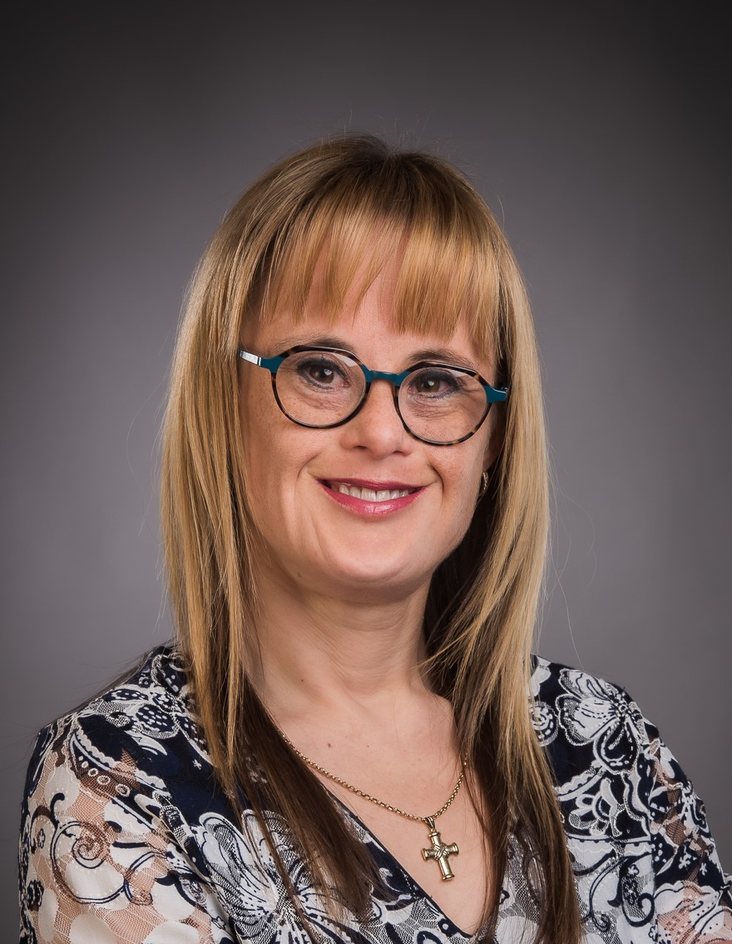
Shéri Brynard (40 years old) of South Africa is the only person with Down syndrome (Trisomy 21) who has a tertiary teacher’s diploma (in Educare), without any amendments been made to the course (or special assistance), in South Africa. This was achieved in spite of the fact that her lectures and her study material was only provided in English, her second language. She is also an international ambassador for all people with Down syndrome, chosen by Down syndrome international (DSi) and she meets with the international ambassadors from other countries once a month virtually. She truly believes that all people have the responsibility to endeavour to make the best of their circumstances and she is a living example thereof. Sheri has also been chosen by her Down syndrome peers as their official South African spokesperson (chairman) for a term of four years. She serves as the South African representative on the Down Syndrome International adult group, who meets every month.
She has also been offered an ad hoc position at the University of the Free State, to assist the different role players in a project, to motivate learners of disadvantaged schools in the Free State. The project was terminated when Covid started. She is still planning to addressed the learners and staff of disadvantaged schools if she can get the opportunity. She believes she is an example of a disadvantaged person (intellectually disabled) because little to no assistance was given to her after she was born. Many like herself were disposed of after birth as medical waste. Doctors wanted to put her in an institution and many like her, is still aborted.
She is currently also a full-time qualified teacher assistant at a Primary School for learners with special educational needs and she presents motivational speeches all over the world. Shéri strives to change negative perceptions about people with Down syndrome and she actively advocates for the rights of all people with any disadvantage to be granted the same opportunities they would have had, if they were more privileged. Although she is intellectually disabled and was educated in the Afrikaans language, she was determined to learn to speak English to be able to reach more people with her story of hope. When she grew up there was little to no support in the form of therapy, etc. available in South Africa.
Apart from the more than 750 public speeches she has presented in South Africa and abroad, Shéri addressed an international conference held at the headquarters of the United Nations in New York and she also addressed the United Nations at a Conference in Geneva, Switzerland. She advocated for the rights of people with intellectual disabilities and addressed many policy makers and ambassadors from various countries. Shéri also had the opportunity to present the opening speech at the International Down Syndrome Conference in 2012 and she did a keynote speech at the opening day of the next International Down syndrome conference, in Chennai, India. Sheri also addressed the International Down syndrome conference in Scotland where she officially represented South Africa and last year she addressed the International Down syndrome conference in Dubai virtually.
Shéri also had the honour to address an education symposium of the University of Canterbury in the UK as well as the delegates of two Oxford Education Symposiums. She now received an Oxford scholarship to do another keynote speech at their Woman Leadership Symposium in December 2022. She also addressed a World Inclusion conference at the Cambridge University in England and she is invited to address a group of post graduate students of the Cambridge University, in December 2022.
Shéri also had the opportunity to address 9 graduation ceremonies of the University of the Free State, which was attended by about 10 000 people and she received a standing ovation every time. She has also appeared on National television in South Africa when she addressed the State President and more than 3 000 guests in Nelspruit.
Apart from the live presentations before and during Covid, Sheri also had the opportunity to do virtual presentations at the World Down syndrome day meetings in New York and in Geneva in 2021 and 2022. Sheri also addressed the Advanced Short Course on Disability Rights in African Context, presented by die University of Pretoria in person and virtually. and she also did a presentation at the African Down Syndrome Network and she addressed the Special Needs Education Conference of the Unity College in Johannesburg. She has also addresses many students of different universities virtually and in person and She has also been interviewed on many television programs and Radio stations nationally and internationally.
Sheri has played talking/ acting parts in the TV soapies “Married to Rugby” and “Binnelanders”. She also hosts her own radio program on Med FM: Just who I am. For the last four years she interviewed many people in and outside the disability sector. Shéri wrote a book about her life and the manuscript was accepted by the Lux Verbi Publisher and the book has been launched internationally in English and Afrikaans. Sheri performed the main role in two different stage dramas, performed at the Free State Arts Festival on the Campus of the University Free State and in the Drostdy theatre in Stellenbosch. These shows were a huge success. Sheri was also featured in a TV program about disabilities on TV2, Activated, in 2021. She has also been invited as guest on many talk shows on television, the latest being on Via, with Minki Van der Westhuizen.
For the last two years Sheri has also been on the steering committee of the Chimes Project. The aim of the project is to prepare 2-4-year old children with intellectual disabilities, physically for a better life. It is an initiative of the Paralympic committee, funded by Bill Gates. Sheri also supports an initiative at a school for learners with physical disabilities financially, to buy wheelchairs for disadvantaged learners. Sheri was one of the initiators to launch meetings for a National Representative group of adult persons with Down syndrome in South Africa. Due to her request to start an adult group for persons with Down syndrome in her home town, such a group has also been started in Bloemfontein.
In 2019 Nupur Chokshi from Boston USA, founder of Inspiration Matters, an online global community for people with disabilities which focuses on enrichment, and celebrates the strengths of all individuals with disabilities, invited Shéri to become part of his initiative to empower his community, by showing examples of people who have been through tough situations and have overcome or faced these challenges. Shéri is also part of research done at the King's College University, to improve the quality of life of people with Down syndrome, especially regarding Alzheimer’s disease and she also addressed a “doctor’s training program” of the King's College University in London. Shéri also addressed different schools and events in different towns in New Zealand. Due to the positive feedback after these speeches, she was invited to for an interview on National Television, Good Morning New Zealand. Shéri also delivered a key note at the 7th Annual Disability Rights Conference for the African region, in Johannesburg.
Shéri has addressed audiences in Windhoek and Swakopmund in a neighbouring country, Namibia, to help them acquire funds for their learners with special needs. Shéri has also been invited to do keynote speeches at the World Conference on Community Nursing in Cape Town and an Education conference in Botswana. In Botswana she also talked to the rural communities and schools and tried to motivate these people to accept their children with disabilities. Sheri then also had the opportunity to address a Down syndrome seminar in the townships in Khayelitsha in Cape Town, where she tried to address the uncertainties of parents and therapists working with children with disabilities and in Lesotho she addressed the “Rural woman of Southern Africa”.
Before Covid Shéri was a member of the Presidential Working group on Disabilities, of South Africa. She has also been invited to be an ambassador for National Casual Day. A full feature was done on Sheri by the international magazine, Kids Nation Magazine, in three consecutive years. She has also been featured by Down syndrome international, on their web page many times. Sheri was featured in an article in a paper in Scotland: Thereworld (UK) and in a Melbourne newspaper, The Age, in Australia
In Aberystwyth in Wales (UK) Shéri gave the main Conference Banquet keynote presentation at the Childs World Conference. Shéri also had the wonderful opportunities to address an International Conference on Disability and Human Development in Jerusalem, Israel and she delivered a keynote speech at the international “Women in Academic Leadership” conference in Johannesburg, a spotlight speech at the European Education Conference in Brighton, UK., the First South African Symposium on Teacher Education for Inclusion, and delivered a paper at the SAERA Conference (an Education conferences in South Africa). All the above was the first time ever for a person with Down syndrome.
She also addressed the World nursing and healthcare Conference in London and her speech was chosen as the presentation which received the best feedback of the conference. She was also the main speaker at a lunchtime seminar of the London University College and delivered a keynote speech at the "9th Euro Nursing and Medicare Summit” which was held in Rome, Italy.
Shéri had the opportunity to do a keynote speech at a conference of the Royal Society of Medicine in London. She also co-presented a workshop: To develop new perspectives and skills in medical practitioners and teachers to assist people with Down syndrome, presented by Belmatt Healthcare Training, in London. She addressed the Inclusion Africa General Assembly and represented South Africa as international self-advocate in 2019. This year she was part of a short course hosted by the Centre for Human Rights, University of Pretoria and she will address the 8th Annual Disability Rights Conference, hosted by the Centre for Human Rights, University of Pretoria. Sheri travelled to Neuchâtel in Switzerland where she addressed a lunchtime seminar at the IHTTI School of Management. She did the opening keynote speech at the 23rd World nursing and healthcare Conference in Berlin, Germany and she was asked to be part of a Down syndrome online summit, organized from Bonn, Germany. She had to present a speech online. This speech and the questions she answered, was presented on the internet (with translations into German). Shéri even had the opportunity to address more than 10 000 people at an amphitheatre on Christmas day in Hartenbos, South Africa. The huge audience gave her a standing ovation.

SHÉRI HAS RECEIVED NUMEROUS AWARDS, LISTED BELOW:
- Nomination as a trailblazer for The Young Independent 100 in the SADC region, by Independent Media in South Africa. They were looking for the young leaders in Southern Africa.

- Shoprite Checkers Woman of the Year in her category, “Youth Movers”, in South Africa, with a disability. She was the first winner ever to receive a standing ovation. There were more than 1 400 nominations.
- The Presidential award (the highest award) for people who have made a contribution to the lives of mentally handicapped people in South Africa. This is a national award and the first time ever that a person with a disability received it.
- Received the World Down Syndrome Day Award in recognition of her efforts to change the lives and perceptions of people with Down syndrome.

- Her book was nominated for: The Andrew Murray-Desmond Tutu prize which acknowledges Christian and theological publications in an official South African language.
- The National Tribute award, which plays tribute to people with disabilities in South Africa who makes a difference in the lives of other people with disabilities.
- The Optentia Award by the University of North West, in South Africa, in acknowledgement of the many contributions she has made in the Southern African context.
- Nominated twice as the Bloemfontein resident of the Year because of the work she is doing nationally and internationally to change perceptions of society about people with Intellectual disabilities.
- The most outstanding youth. Best Achiever Award” on National and International level in the Free State, from the Premier of the Free State.
- 2019: Shéri was honoured as one of the inspirational women in South Africa by the magazine, Sarie.

SOME MORE WONDERFUL OPPORTUNITIES

2018: Sheri was featured in Oprah's Magazine.

2019: Shéri was invited on the TV program Good Morning New Zeeland, where she was interviewed on National Television in New Zeeland.

2021: National Self-Advocacy Launch: DSSA launched the national Self-Advocacy group on the 4th March 2021. It was on a virtual platform to “Connect” the representative voices of young adults with Down syndrome, speaking on matters that affect them in their daily lives. The Self-Advocacy platform was chaired by the Chairperson of the Self-Advocacy movement, Sheri Brynard.
2022: Sheri also started a Self-Advocacy movement in her home town, Bloemfontein, in South Africa. Many of these adult persons with Down syndrome cannot read, write or speak clearly. We are trying to address these and many other barriers in their lives.

Sheri has again been featured by the "Kids Nation" international virtual magazine in September 2021 and a number of times, and in a paper in Scotland: Thereworld (UK): https://theirworld.org/news/downs-syndrome-teacher-inspires-pre-primary-special-needs-children-sherie-brynard and she s was part of a feature article about the Congress in Scotland, by Elizabeth Callinan, in a Melbourne newspaper, The Age in Australia.
SHERI IS PROUD TO BE PART OF THE FOLLOWING RESEARCH AND PROJECTS:
Shéri has been part of research (by the LonDownS consortium) in London for the last 7 years. They did research to investigate differences in cognitive functions in people with Down syndrome and the possible genetic and biological reasons for these differences. Cognitive markers of preclinical and prodromal Alzheimer’s disease in Down syndrome were also investigated.
In 2019/21 Shéri assisted the LonDownS team at King's College to start with new research on people with Down syndrome, where more invasive methods were used. She underwent a lumbar punch and they drew her blood. In 2021 the researchers did an MRI scan of her brain, to help future generations of people with and without Down syndrome; to find a possible cure for Alzheimer’s disease. This procedure will be repeated in 2022.

RESEARCH IN 2022:

MinDSets
Sheri was invited and takes part in the following research study: Dr Dan Gordon at Anglia Ruskin University (Cambridge, UK) on the MinDSets research study in collaboration with the Canadian Down Syndrome Society. The effect of physical activity on the cognitive development on older persons with Down syndrome will be researched

LONDOWNS PROJECT
Sheri was used for interviews for research, that run alongside the LonDownS project, to hear from people with Down syndrome about their views on aging and healthcare, on the 16th March. She will again go to London in November for the research on Alzheimer's on her physically and cognitively.
CHIME PROJECT:
Sheri again had a number of virtual meetings, being part of the steering committee of the Chime Project, sponsored by the “Bill & Melinda Gates foundation”. The purpose of this work is to develop an intervention of the Special Olympics to expand the reach of its maternal and child health programs in conjunction with the UAE (most recent host of the special Olympics Games).
UNSTOPPABLE PROJECT:
SADA, being recognized as the ‘voice in the disability sector’ in South Africa, proposes that the UNSTOPPABLE Project become a flagship for disability advocacy. They also want to look at the possibility of leveraging this as an income generator for their organization which will help keep them sustainable to continue their efforts.

Shortened Bio
Shéri Brynard is the only person with Down syndrome who has a tertiary teacher’s diploma without any amendments or special assistance, in South Africa. This was achieved in spite of the fact that her lectures and her study material was only provided in English, her second language. She is also an international ambassador for all people with Down syndrome, chosen by Down syndrome international (DSi). She truly believes that all people have the responsibility to endeavour to make the best of their circumstances and she is a living example thereof.
Shéri has addressed many disadvantaged schools to help disadvantaged learners in the Free State. She is currently also a full-time qualified assistant teacher at a Primary school for learners with special educational needs and she presents motivational speeches all over the world. Shéri is intellectually disabled and lives a full life because she was educated in a mainstream environment and that helped her to acquire an Education Diploma without any amendments or special assistance, which serves as example to all people.
Shéri strives to change negative perceptions about people with Down syndrome and she actively advocates for the rights of all people with any disadvantage internationally. Shéri strives to change negative perceptions about people with Down syndrome and she actively advocates for the rights of all people with any disadvantage. Sheri has presented more than 750 speeches (on invitation) Nationally and Internationally. In December she will again address the post-graduation students of the University of Cambridge (UK). Sheri also received an Oxford invitation, to do another keynote speech at their Woman Leadership Symposium in Oxford.

